**Sheet No. – 01**

**Assignment No: 1**

1. **Creation of Tables:**

**(i). Creation of depts table:**

**Query:**

create table depts(

deptcode char(3) primary key,

deptname char(30) not null);

**Inserting values:**

insert into depts (deptcode, deptname)

values

('CE', 'Civil'),

('CSE', 'Computer Science'),

('ELE', 'Electrical');

**depts table after insertion of values:**

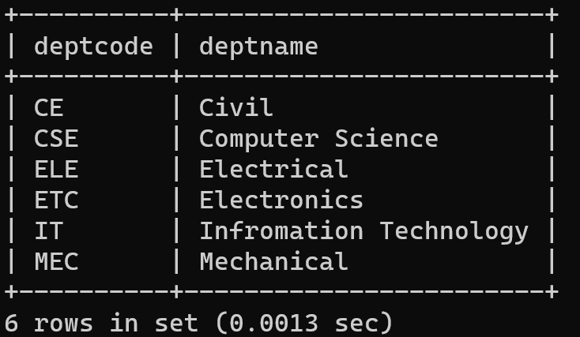

**(ii). Creation of students table:**

**Query:**

create table students(

rollno numeric(8) primary key,

name char(30),

bdate date check(bdate < '1997-01-01'),

deptcode char(3) references depts(deptcode)

on delete cascade,

hostel numeric check(hostel<10),

parent_inc numeric(8,1));

**Inserting values:**

insert into students (rollno, name, bdate, deptcode, hostel, parent_inc)

values

(92005101, 'Oishika Dutta', '1996-07-22', 'CSE', 4, 370000.0),

(92005102, 'Lasiewdor Rapsang', '1996-12-05', 'IT', 4, 450000.0),

(92005108, 'Debargha Ghosh', '1996-09-09', 'ELE', 5, 88630.0),

(92005201, 'Anish Banerjee', '1995-08-03', 'CSE', 7, 500000.0);

**students table after insertion of values:**

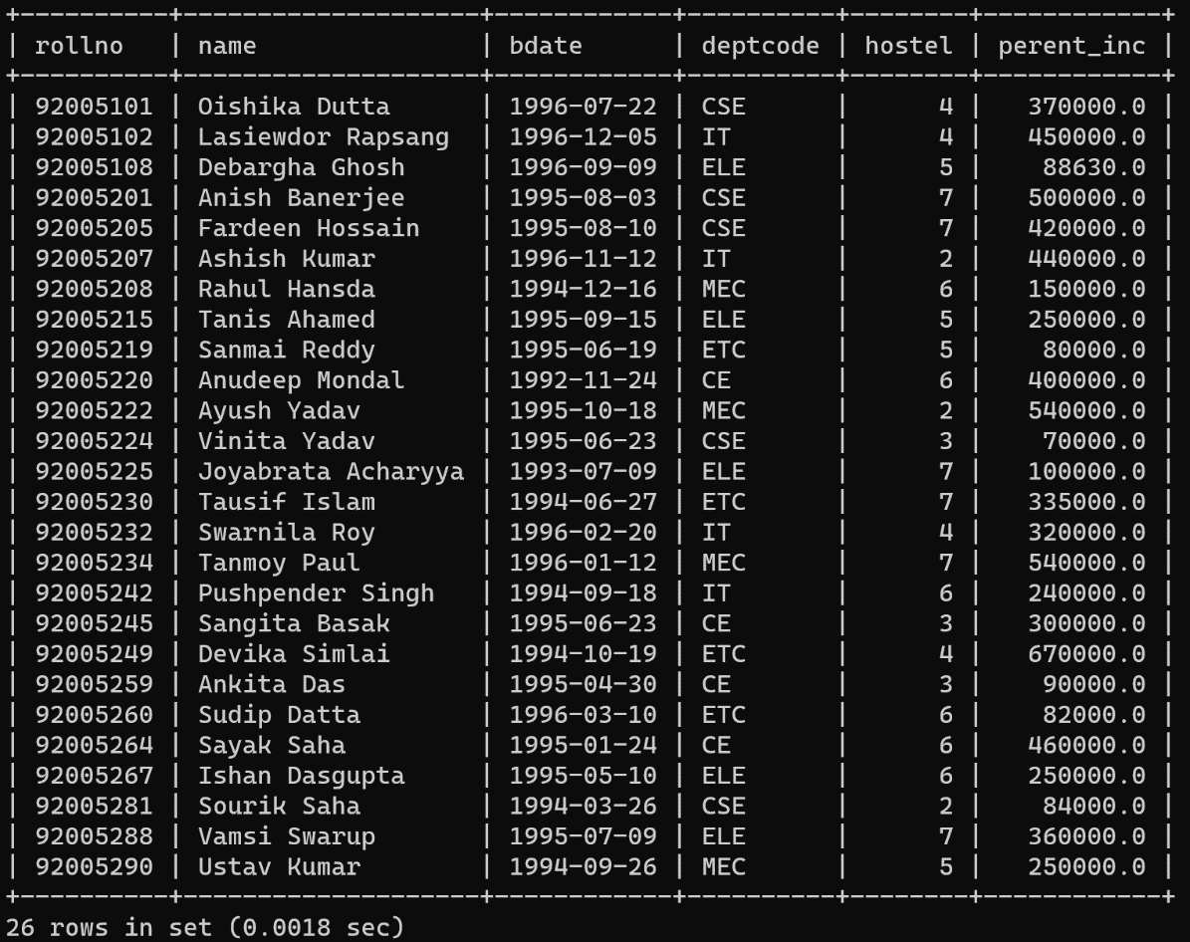

**(iii). Creation of faculty table:**

**Query:**

create table faculty(

fac_code char(8) primary key,

fac_name char(30) not null,

fac_dept char(3) references depts(deptcode));

**Inserting values:**

insert into faculty (fac_code, fac_name, fac_dept)

values

('AB', 'Aritra Banyopadhyay', 'ELE'),

('ARB', 'Aheli Roy Banerjee', 'MEC'),

('dbp', 'Bipradeep Bera', 'ETC'),

('MT', 'Manas Tripathi', 'CSE'),

('nls', 'Pratik Srivastav', 'CE');

**faculty table after insertion of values:**

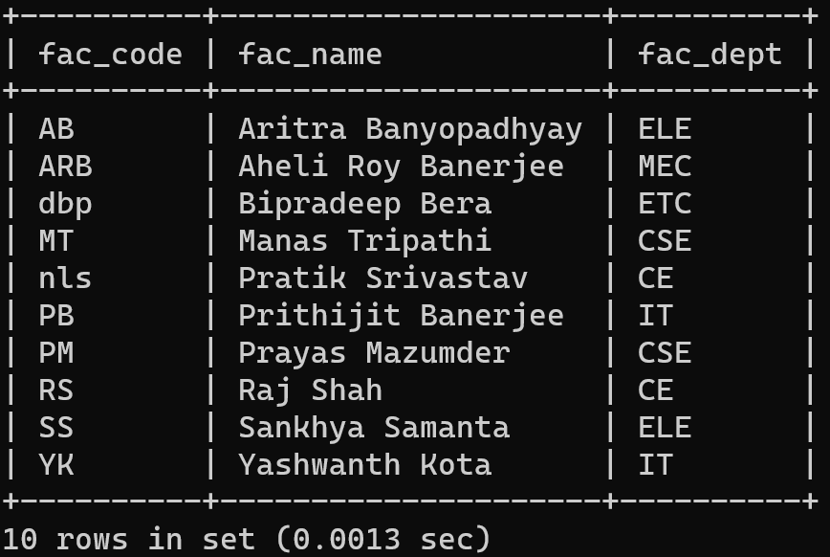

**(iv). Creation of crs_offrd(course offered) table:**

**Query:**

create table crs_offrd(

crs_code char(5) primary key,

crs_name char(35) not null,

crs_credits numeric(2,1),

crs_fac_cd char(8) references faculty(fac_code));

**Inserting values:**

insert into crs_offrd (crs_code, crs_name, crs_credits, crs_fac_cd)

values

('CE201', 'Water Resources', 6.0, 'RS'),

('CE204', 'Building Material', 8.2, 'nls'),

('CS101', 'OS', 9.0, 'PM'),

('CS201', 'Software Engg', 8.5, 'MT'),

('CS207', 'DBMS', 8.0, 'PM');

**crs_offrd table after insertion of values:**

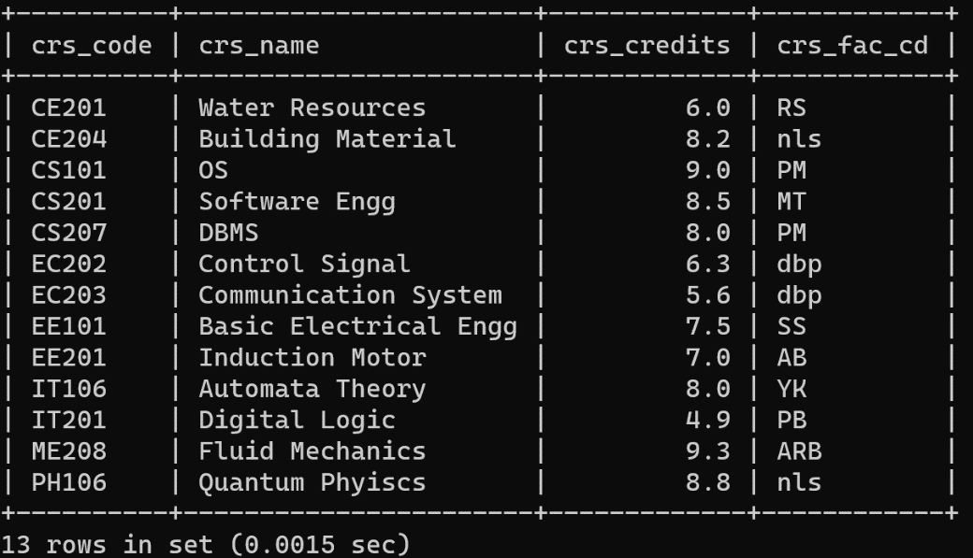

**(iv). Creation of crs_regd(course registered) table:**

**Query:**

create table crs_regd(

crs_rollno numeric(8) references students(rollno),

crs_cd char(5) references crs_offrd(crs_code),

marks numeric(5,2),

primary key(crs_rollno,crs_cd));

**Inserting values:**

insert into crs_regd (crs_rollno, crs_cd, marks)

values

(92005101, 'CS101', 89.00),

(92005101, 'CS201', 59.00),

(92005101, 'CS207', 76.00),

(92005102, 'IT106', 68.00),

(92005102, 'IT201', 100.00),

(92005201, 'CS101', 92.00),

(92005201, 'CS201', 56.00),

(92005201, 'CS207', 98.00);

**crs_regd table after insertion of values:**

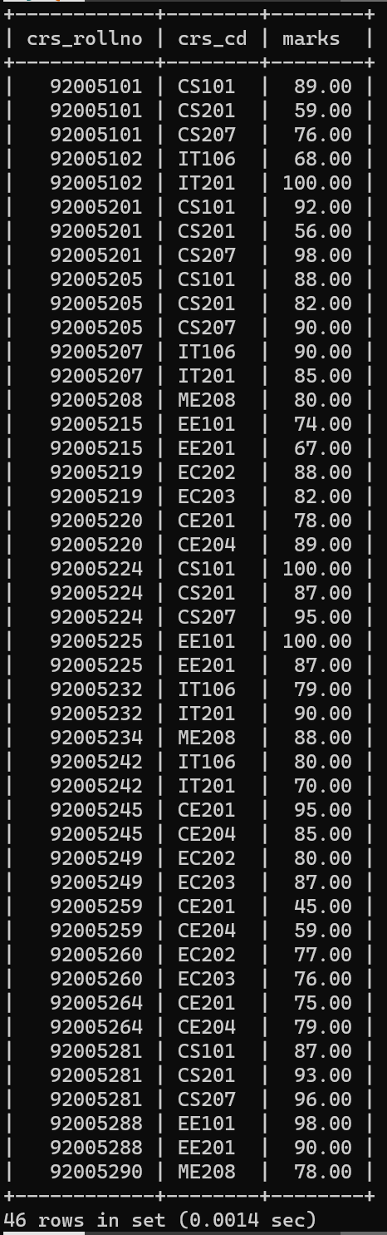

1. **Queries and their solutions:**
2. **Try inserting records which violate the constraints:**

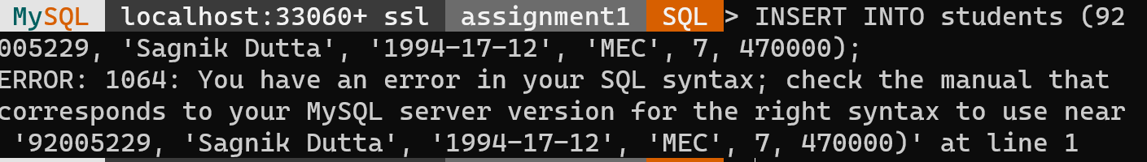

**Explanation:**

Here it is showing error because, while creating the table ‘students’ , I added a check constraint that is bdate date check(bdate < '1997-01-01'). But here I added ‘1994-17-12’ where correct formatting of date is not used. Therefore check constraint is violated here.

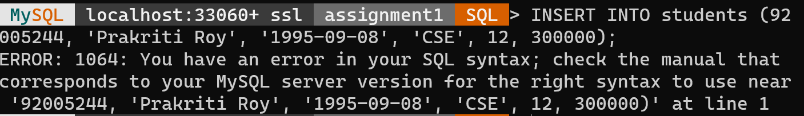

**Explanation:**

Here it is showing error because, at the time of creation of table ‘students’, a check constraint was added that hostel numeric check(hostel<10). But I entered value 12. So check constraint is violated here.

1. **Delete records from dept where deptcode='CSE'. (This deletes records from students whose deptcode='CSE'):**

**Query:**

delete from dept

where deptcode=‘CSE’;

**Output:**

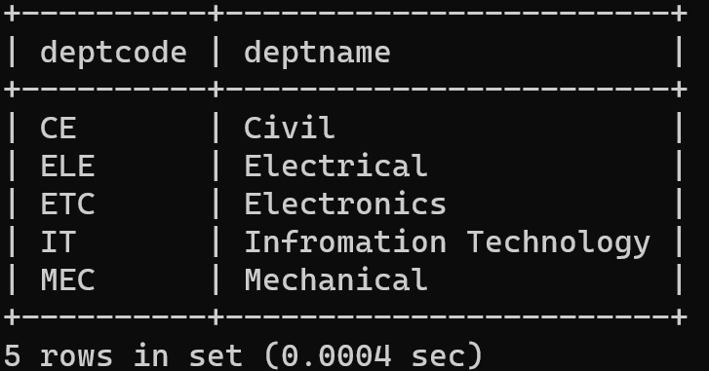

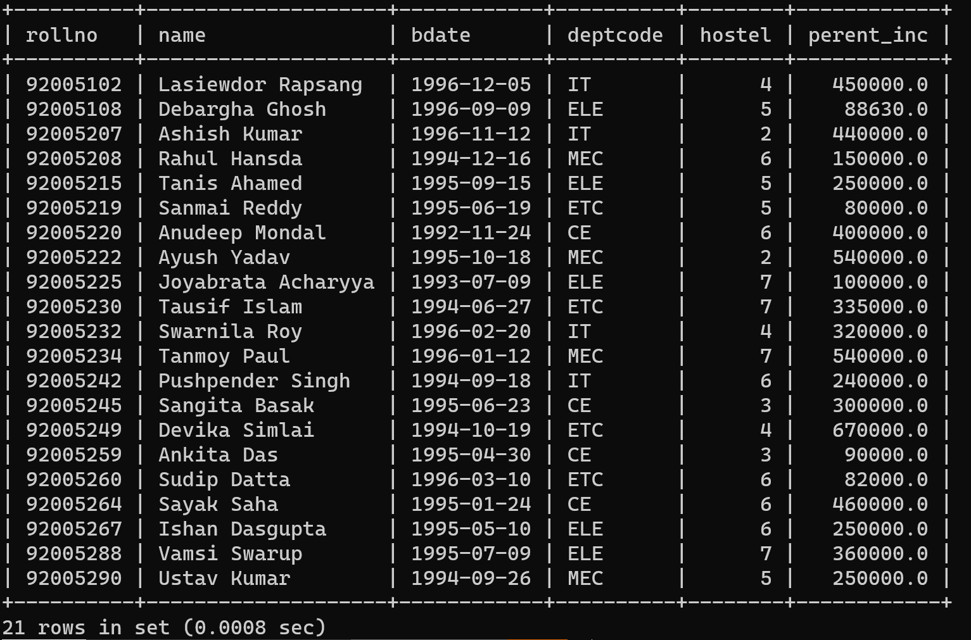

The result shows that the students who have deptocde as ‘CSE’ are removed from the students as well as from the depts table.

1. **Find out the courses offered by the faculty dbp and nls:**

**Query:**

select *

from crs_offrd

where crs_fac_cd IN (‘dbp’, ‘nls’);

**Output:**

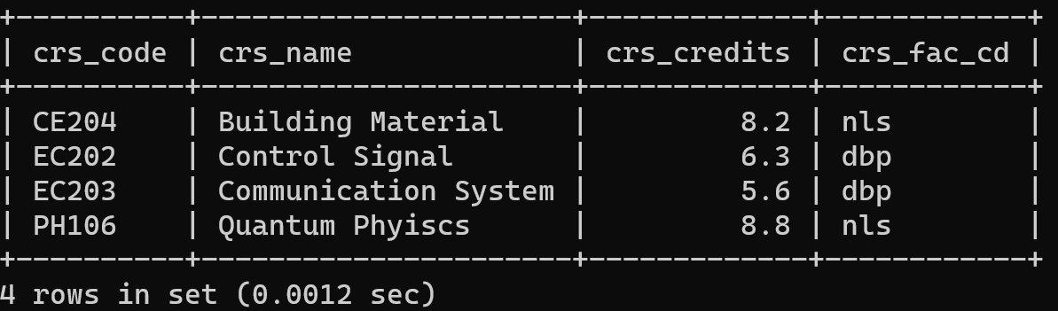

1. **Find out the courses with full details offered by dbp:**

**Query:**

select *

from crs_offrd

where crs_fac_cd = 'dbp';

**Output:**

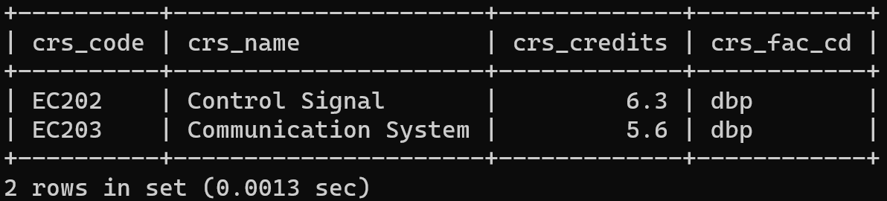

1. **Get the courses the credits of which lies between 4.0 and 6.0:**

**Query:**

select *

from crs_offrd

where crs_credits BETWEEN 4.0 AND 6.0;

**Output:**

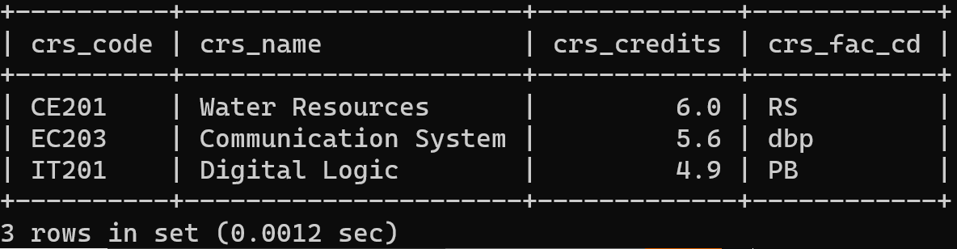

1. **Get the courses the credits of which are > 6.5:**

**Query:**

select *

from crs_offrd

where crs_credits > 6.5;

**Output:**

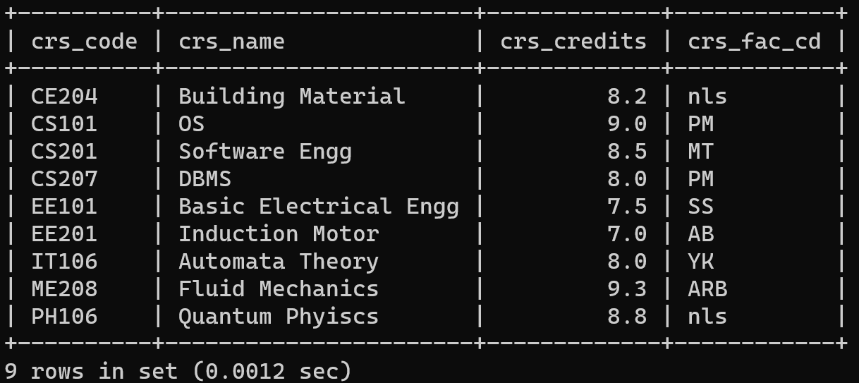

**Assignment No : 2**

1. **Count the number of students in CSE dept:**

**Query:**

select COUNT(*) AS num_students

from students

where deptcode = 'CSE';

**Output:**

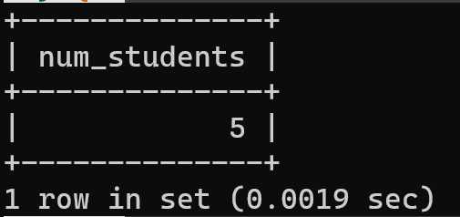

1. **Determine the minimum, maximum and average marks of each courses:**

**Query:**

select crs_cd,

       MIN(marks) AS min_marks,

       MAX(marks) AS max_marks,

       AVG(marks) AS avg_marks

from crs_regd

GROUP BY crs_cd;

**Output:**

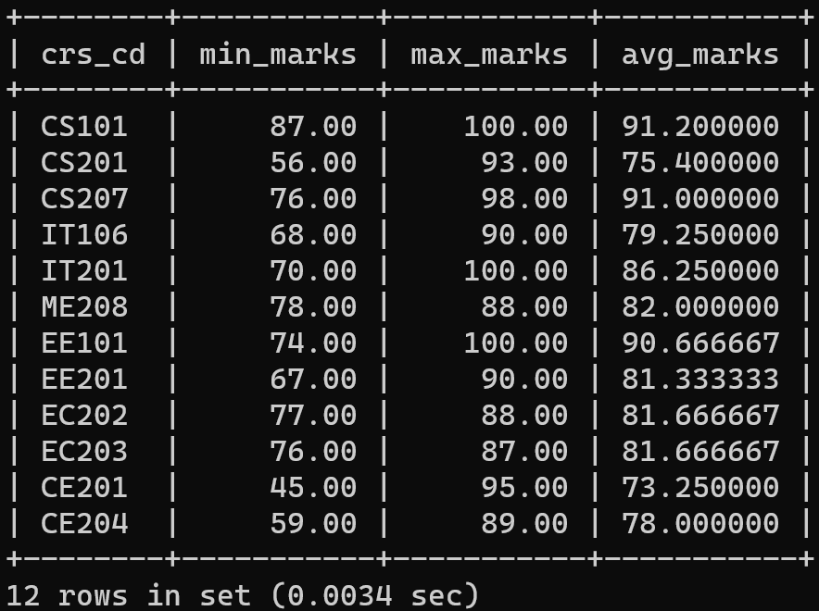

1. **Determine the total credits of the courses registered by a student:**

**Query:**

select cr.crs_rollno, SUM(co.crs_credits) AS total_credits

from crs_regd cr, crs_offrd co where cr.crs_cd = co.crs_code

group by cr.crs_rollno;

**Output:**

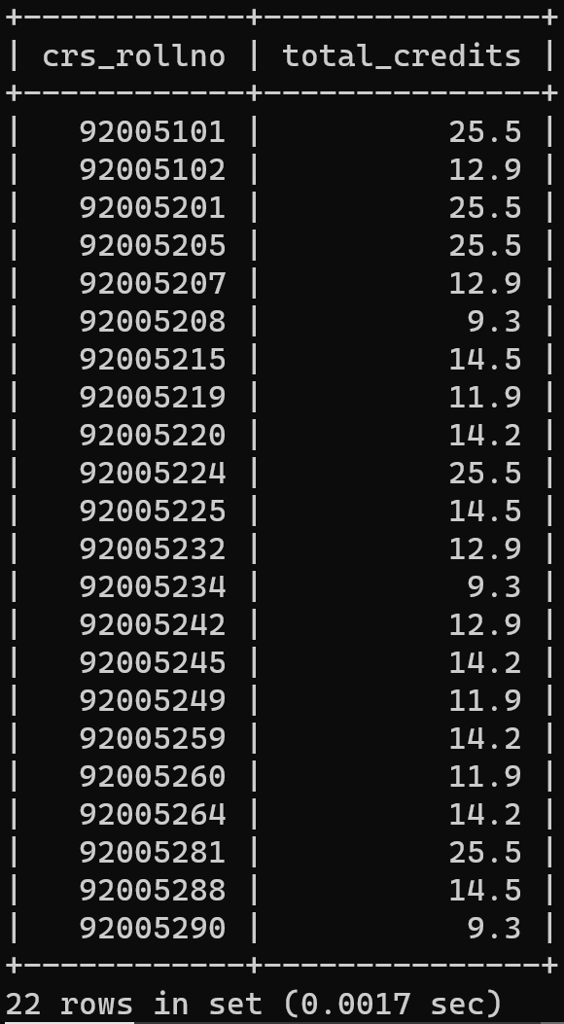

1. **Count the number of students in each hostel whose department is CSE:**

**Query:**

select s.hostel, COUNT(*) AS num_students

from students s

where s.deptcode = 'CSE'

group by s.hostel;

**Output:**

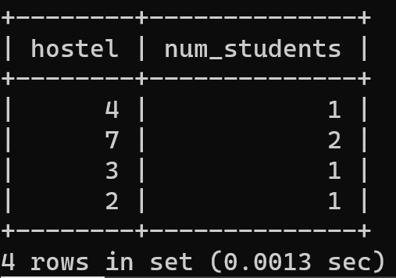

1. **Display the hostel, rollno, parent_inc of the student who has the max(parent_inc) in a hostel:**

**Query:**

Select hostel, rollno, perent_inc

from students

where perent_inc in (select max(perent_inc)

from students

group by hostel)

ORDER BY hostel;

**Output:**

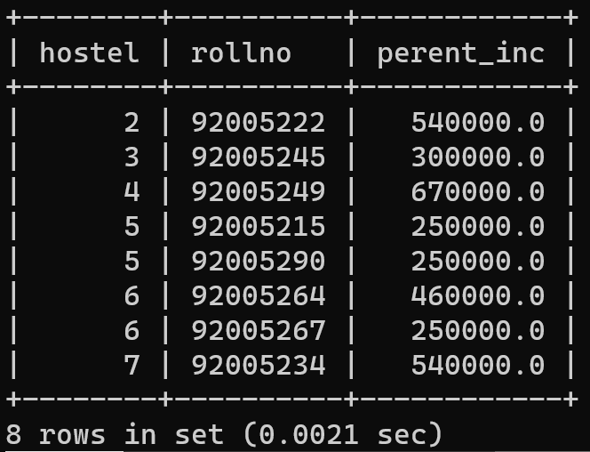

1. **Display the name and parental income of each student greater than the parental income of some rollno 92005008:**

**Query:**

select name, perent_inc

from students

where perent_inc > (select perent_inc

from students

where rollno = 92005208);

**Output:**

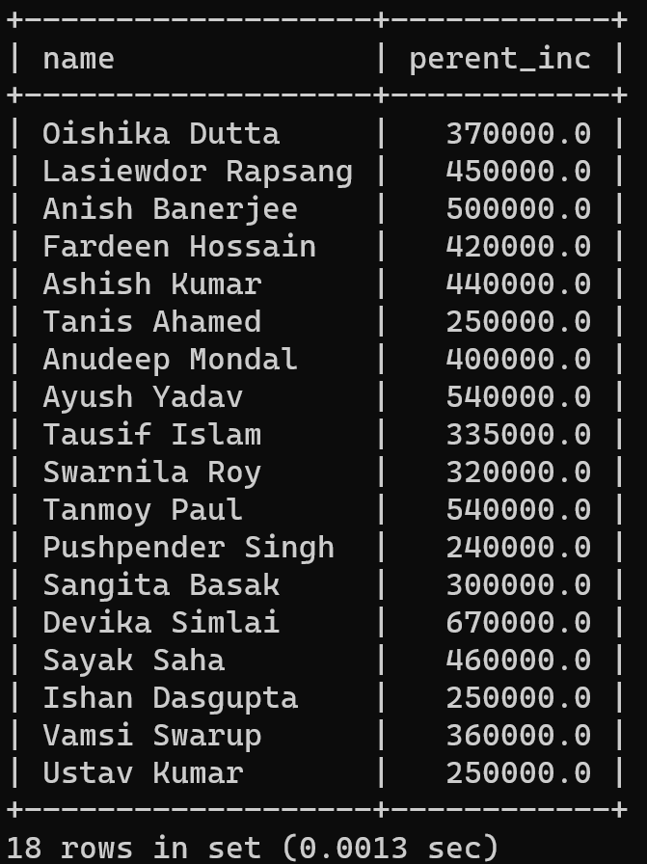

1. **Find out marks of students who have marks more than rollno 92005102 for course CH103 and PH106:**

**Query:**

select crs_rollno, crs_cd, marks

from crs_regd

where(

(

crs_cd = 'CE201'

AND

marks > (

select marks

from crs_regd

where crs_rollno = 92005102 AND crs_cd = 'CE201'

)

)

OR

(

crs_cd = 'PH106'

AND

marks > (

select marks

from crs_regd

where crs_rollno = 92005102 AND crs_cd = 'PH106'

)

)

);

**Output:**

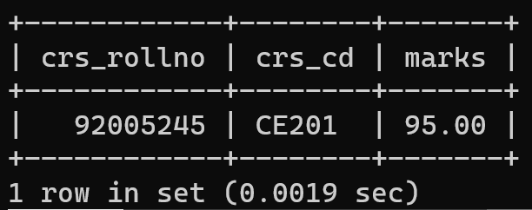

**Assignment No : 3**

1. **List students (rollno, name, deptcode) registered for course EE101:**

**Query:**

select rollno, name, deptcode

from students, crs_regd

where

crs_rollno = rollno

AND crs_cd = 'EE101';

**Output:**

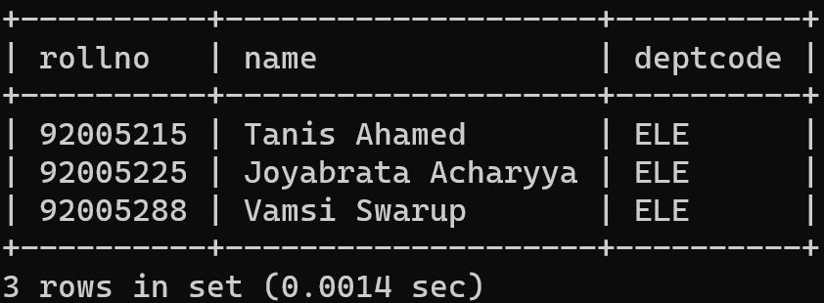

1. **List students (rollno, name) in ELE dept registered for course EE101:**

**Query:**

select rollno, name

from students, crs_regd

where

crs_rollno = rollno

AND deptcode = 'ELE'

AND crs_cd = 'EE101';

**Output:**

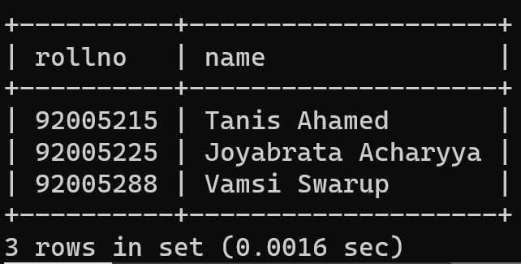

1. **List students (rollno, name) in ELE dept not registered for course EE101:**

**Query:**

select s.rollno, s.name

from students s, crs_regd c

where c.crs_rollno = s.rollno

AND s.deptcode = 'ELE'

EXCEPT

select s.rollno, s.name

from students s, crs_regd c

where c.crs_rollno = s.rollno

AND s.deptcode = 'ELE'

AND c.crs_cd = 'EE101';

**Output:**

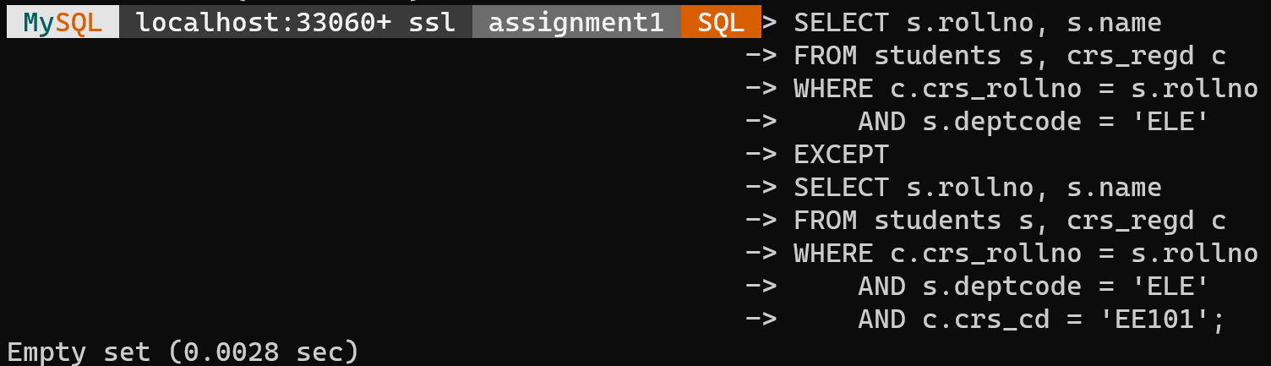

This returns an empty set because there are no students who does not enrolled in any of the courses. ELE department students have enrolled in all the departmental courses.

1. **List the names of the students who have registered for both the courses 'DBMS' and 'OS':**

**Query:**

select name

from students, crs_regd, crs_offrd

where

crs_rollno = rollno

AND crs_cd = crs_code

AND crs_offrd.crs_name = 'DBMS'

INTERSECT

select name

from students, crs_regd, crs_offrd

where

crs_rollno = rollno

AND crs_cd = crs_code

AND crs_offrd.crs_name = 'OS';

**Output:**

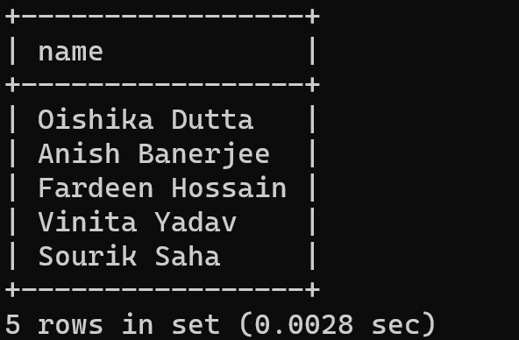

1. **Find the names of the faculty members who have offered either 'Automata Theory' or 'Software Engg.':**

**Query:**

select fac_name

from faculty, crs_offrd

where

crs_fac_cd = fac_code

AND crs_name = ‘Automata Theory'

UNION

select fac_name

from faculty, crs_offrd

where

crs_fac_cd = fac_code

AND crs_name = 'Software Engg';

**Output:**

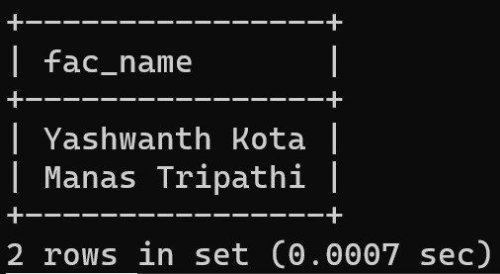

1. **Find the names of the faculty members who have offered 'Automata Theory' but not offered 'Software Engg.':**

**Query:**

select fac_name from faculty, crs_offrd

where

fac_code = crs_fac_cd

AND crs_name = 'Automata Theory'

EXCEPT

select fac_name

from faculty, crs_offrd

where

fac_code = crs_fac_cd

AND crs_name = 'Software Engg';

**Output:**

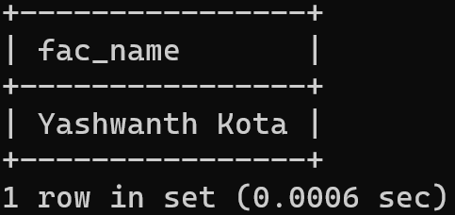

1. **Find out the students in each hostel who are not registered for any course:**

**Query:**

(SELECT rollno, name, hostel

FROM students

WHERE rollno NOT IN (SELECT crs_rollno FROM crs_regd))

UNION

(SELECT rollno, name, hostel

FROM students

WHERE rollno IN (SELECT crs_rollno FROM crs_regd)

AND rollno NOT IN (SELECT rollno FROM students WHERE rollno IN (SELECT crs_rollno FROM crs_regd)))

ORDER BY hostel;

**Output:**

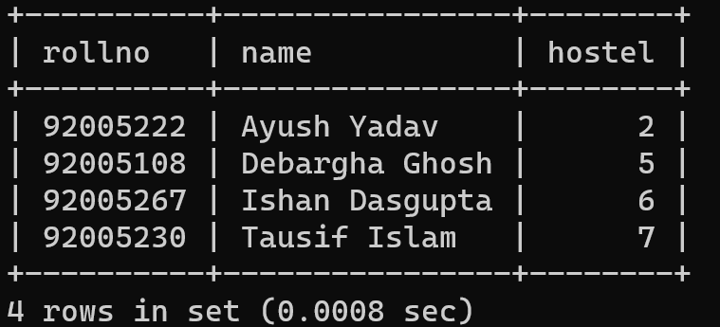

1. **Select the students who are in ELE dept or who have registered for course CS101:**

**Query:**

select rollno, name, deptcode

from students

where deptcode = 'ELE'

UNION

select rollno, name, deptcode

from students, crs_regd

where

rollno = crs_rollno

AND crs_cd = 'CS101';

**Output:**

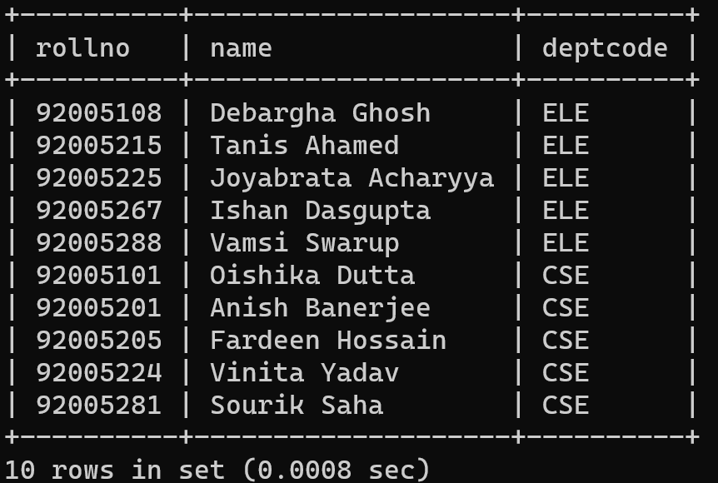

1. **Display the students who have registered to all the courses:**

**Query:**

select crs_rollno, name, deptcode

from students, crs_regd

where rollno = crs_rollno

group by crs_rollno, rollno

HAVING COUNT(*) = (SELECT COUNT(*) from crs_offrd);

**Output:**

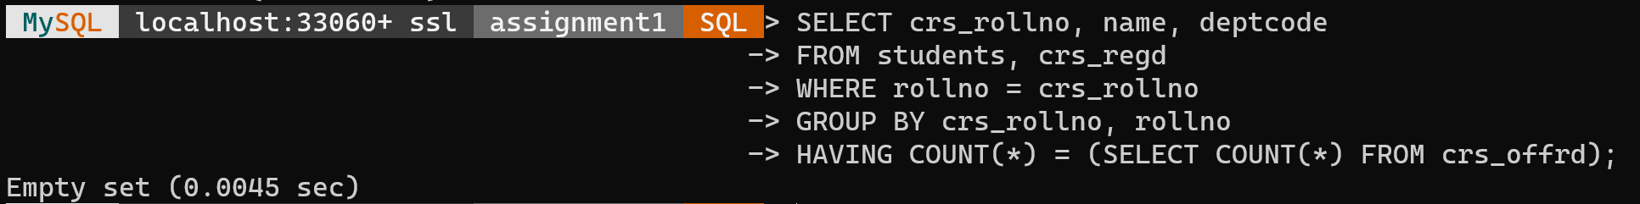

This returns an empty set because there are no students who has registered to all the courses.

1. **Give Grace Marks 5 in subject ‘DBMS’ to the students who have scored less than 50 in that subject:**

**Query:**

UPDATE crs_regd

SET marks = marks + 5

FROM crs_offrd

WHERE

crs_code = crs_cd

AND crs_name = 'DBMS'

AND marks < 50;

**Output:**

